CV of Ryoma Sakamoto

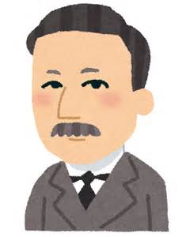

1-2-3 Sensui, Tobata

Kitakyushu, Fukuoka 804-1234

JAPAN

Phone: +81-80-2257-321, e-mail: ryoma.sakamoto@mail.kyutech.jp

OBJECTIVE: To obtain an internship in Robotics

EDUCATION: 2017 1st year in Master’s Program, Department of Mechanical and

Control Engineering, Graduate School,

Kyushu Institute of Technology

2014/2017 Control Engineering Course, Department of Mechanical and

Control Engineering, Undergraduate School,

Kyushu Institute of Technology

CURRENT RESEARCH: Robust Controller Design of Helicopter Flight

SKILLS & QUALIFICATIONS: Skilled in Matlab, MS Office, MS Excel, C programming

English – Appropriate working knowledge

RELEVANT EXPERIENCE: July-August 2015, Internship at Mitsubishi Electric Co., Tokyo

ACTIVITIES: Member of American Football Club of Kyutech

Hobbies: Tennis, Swimming, Skiing

